INDEPENDENT CONTRACTOR GUIDANCE

Who is an Independent Contractor?
An Independent Contractor is an individual who performs services for the business whereby the business has the right to specify the result to be accomplished by the work, but not the means and methods by which the result is to be accomplished. The earnings of a person who is working as an independent contractor are subject to Self-Employment Tax. Businesses generally do not have to pay any taxes on payments to independent contractors.
An Independent must meet the following criteria:
- Is not currently an employee of the University
- Has no expectation of becoming an employee at the end of the contractual service
- Relied or will rely upon own expertise rather than following instructions from the department regarding performance of the required work
- Performed the work to the specifications of, but not under the direction of, a University employee or student
- Did not have the required number of work hours and/or day of the week set by the University
In contrast, an employee is anyone who performs services for the business and the business controls what will be done and how it will be done. The business must withhold income taxes, withhold and pay Social Security and Medicare taxes, and pay unemployment taxes on wages paid to the employee.
Federal and state tax laws require Emory University to ensure that individuals who provide services are properly classified as an employee or independent contractor. Proper classification of an individual will determine Emory's tax withholding and reporting obligations.
Determining if the Individual is an Independent Contractor
Degree and Control
In determining whether the person providing service is an employee or an independent contractor, all information that provides evidence of the degree of control and independence must be considered.
Factors that provide evidence of the degree of control and independence fall into three categories:

1. BEHAVIORAL
Does the company control or have their right to control what the worker does and how the worker does his job?

2. FINANCIAL
Are the business aspects of the worker's job controlled by the payer? (These include things like how the worker is paid, whether expenses are reimbursed, and who provides the tool/supplies, etc.)

3. TYPE OF RELATIONSHIP
Are there written contracts or employee type benefits (i.e., pension plan, insurance, vacation pay, etc.)?
Will the relationship continue and is the work performed a key aspect of the business?
All these factors must be weighed by the business when determining whether the person is an employee or an independent contractor. It is not always easy to make the determination and there is no one factor that ultimately stands alone in making the determination.
Per the IRS, the key is to look at the entire relationship, consider the degree or extent of the right to direct and control, and finally, to document each of the factors use in coming up with determination.
Classification with the IRS
IRS can make the determination for you
If, after reviewing the Behavioral, Financial and Type of Relationship factors, and it is still unclear if the person should be classified as an employee or an independent contractor, you can complete Form SS-8, Determination of Worker Status for Purposes of Federal Employment Taxes and Income Tax Withholding. Send the form to the IRS and they will make the determination for you. However, note that it can take up to six months to make that determination.
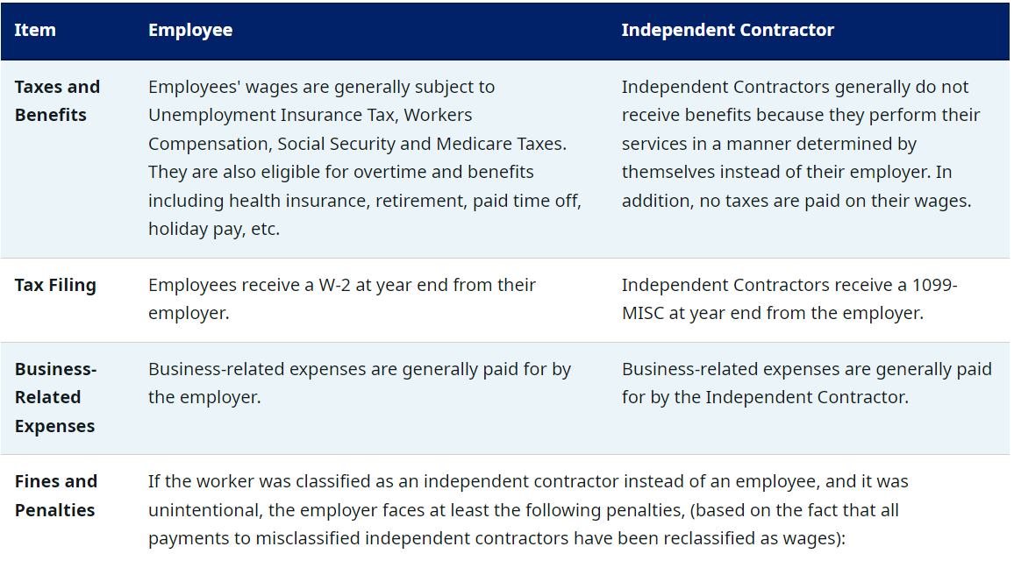
Proper Worker Classification Affects:

Fines and Penalties
- Wages that should have been paid to them under the Fair Labor Standards Act, including overtime and maximum wage; Back taxes and penalties for federal and state income taxes, Social Security, Medicare and Unemployment; Any misclassified injured employee's worker's compensation benefits; Employee benefits including health insurance, retirement, etc.
- $50 for each Form W-2 that the employer failed to file because of classifying the worker as an independent contractor.
- Since the employer failed to withhold income taxes, it faces penalties of 1.5% of the wages, plus 40% of the FICA taxes (Social Security and Medicare) that were not withheld from the employee and 100% of the matching FICA taxes the employer should have paid. Interest is also accrued on these penalties daily from the date they should have been deposited.
- A Failure to Pay Taxes penalty equal to 0.5% of the unpaid liability for each month up to 25% of the total tax liability.
- If the IRS suspects fraud or misintentional misconduct, it can impose additional fines and penalties. For instance, the employer could be subjected to penalties that include 20% of all the wages paid, plus 100% of the FICA taxes, both the employee's and the employer's share.
- Criminal penalties of up to $1,000 per misclassified worker and one year in prison can be imposed as well. In addition, the person responsible for withholding taxes could also be held personally liable for any uncollected tax.

