How to Request a Travel Cash Advance in Compass

The following are instructions on how to request a travel cash advance.
Steps:
- Log into Compass Financials
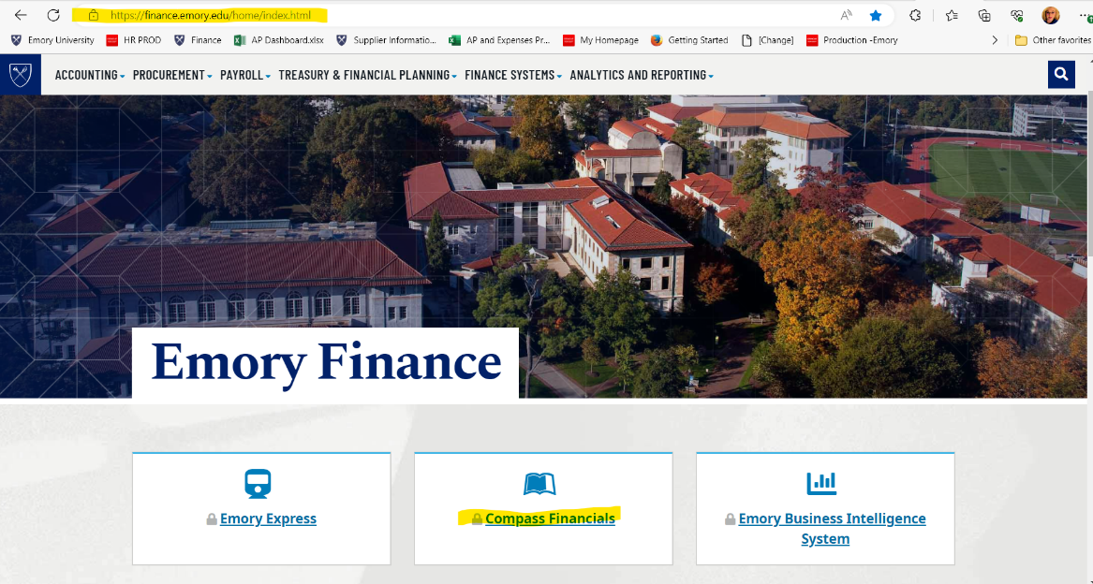
On the Emory Finance home page (Emory Finance | Finance | Emory University), click on the Compass Financials Tile.

- Click on Travel and Expense Center Tile
On the Compass Dashboard, click on the Travel and Expense Center tile.
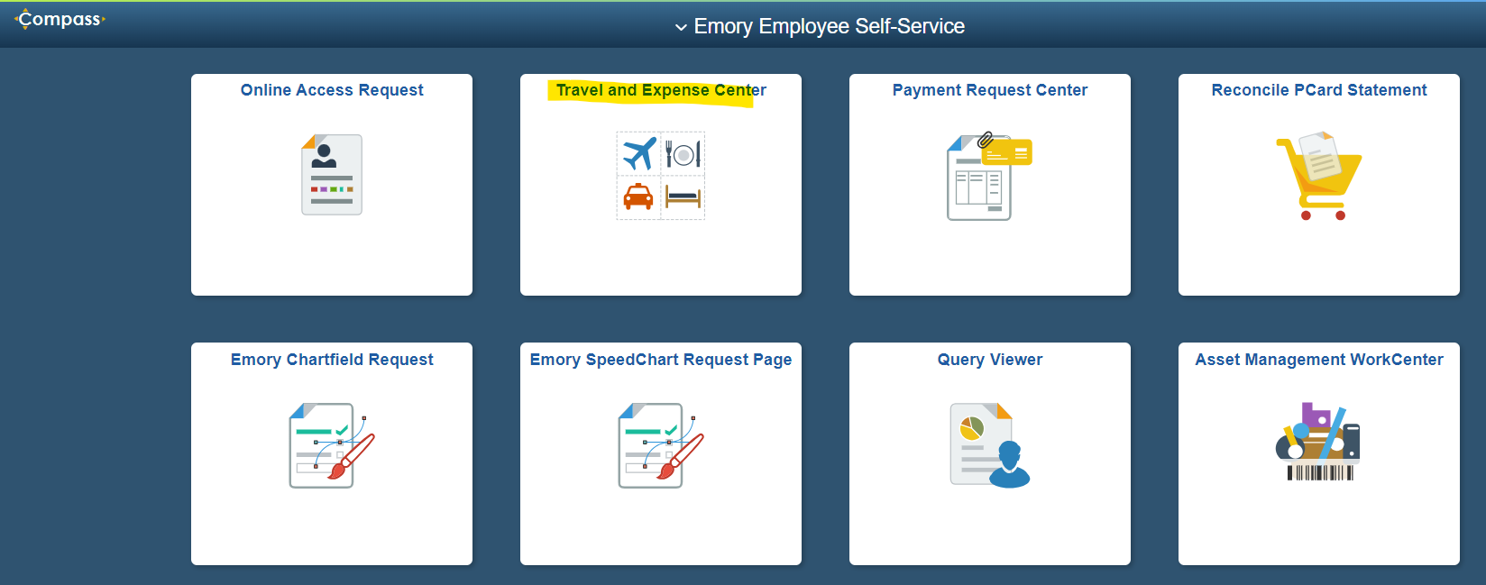

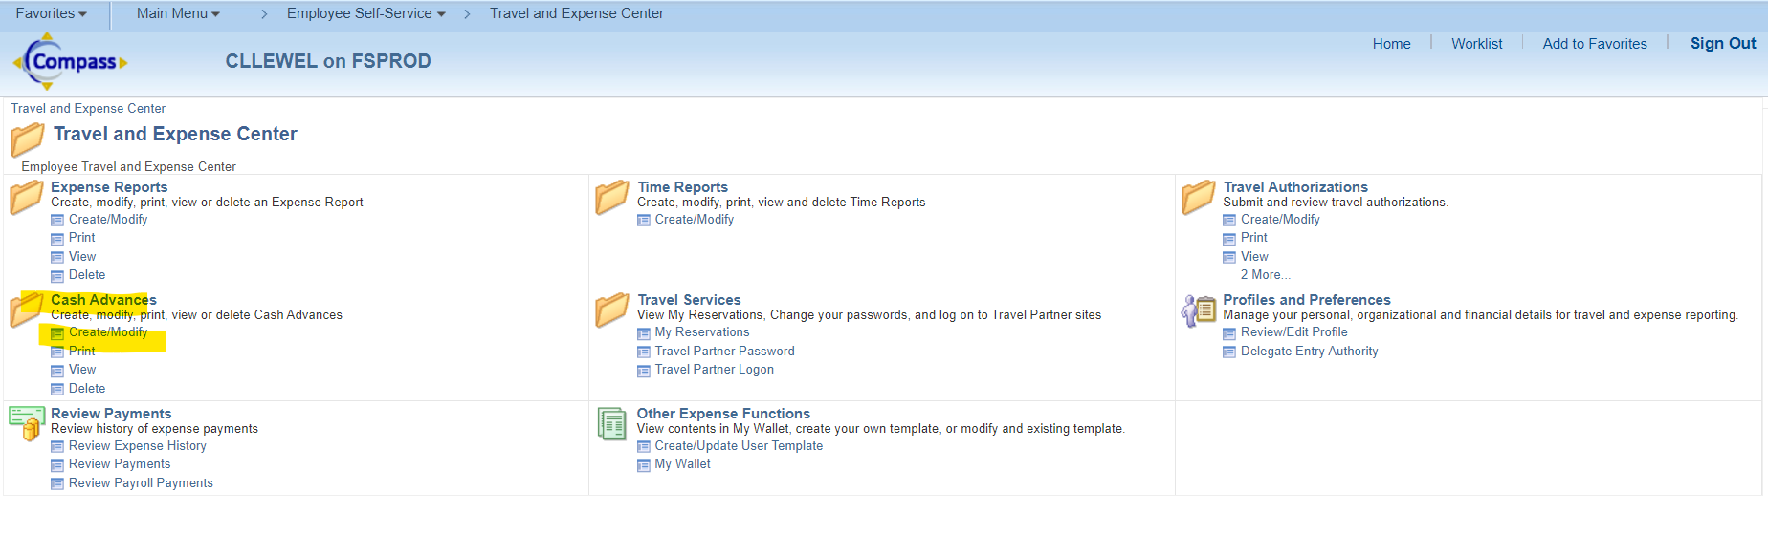
- Access the Cash Advances Form
- Click on the Create/Modify under the Cash Advances folder.

- Add a New Value
Your Employee ID will automatically default in the *Empl ID field. If you are submitting for someone else, please be sure to enter their employee identification number.
- Click the Add a New Value tab.
- Click Add.

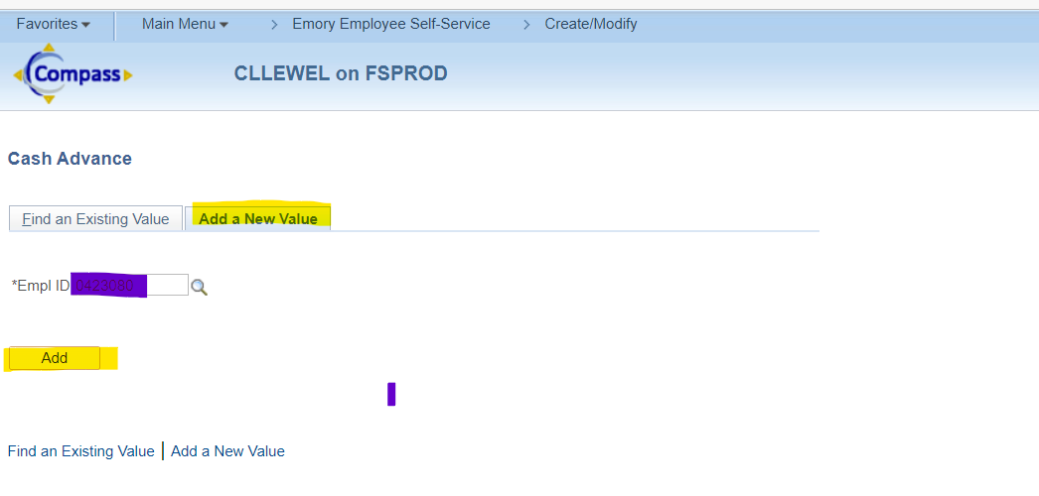

- Create a Cash Advance
Complete the fields on the Cash Advance Form:
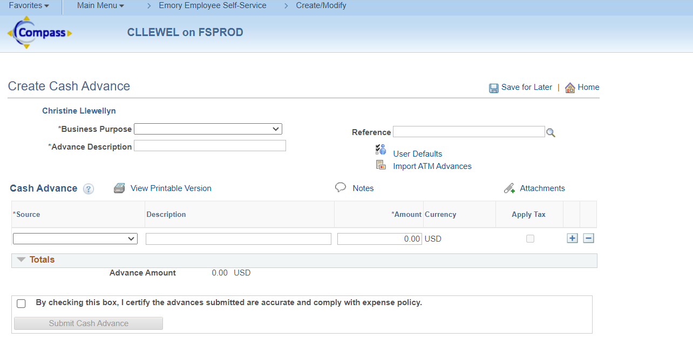

- Select your Business Purpose
- Click on the down arrow next to the Business Purpose to retrieve a list of business purposes.
Business Purpose Options:
- Athletics – General
- Athletics – NCAA
- Athletics – UAA
- Clinical/Site Visits
- Conference/Seminar
- Departmental Expenses
- Donor Visit
- Faculty/Staff Recruiting
- Fundraising
- Meeting
- Professional Development
- Research/Fieldwork
- Special Events
- Student Recruiting

- Select the business purpose that meets your request.

- Advance Description Field
- In the Advance Description field, add more information regarding your request.
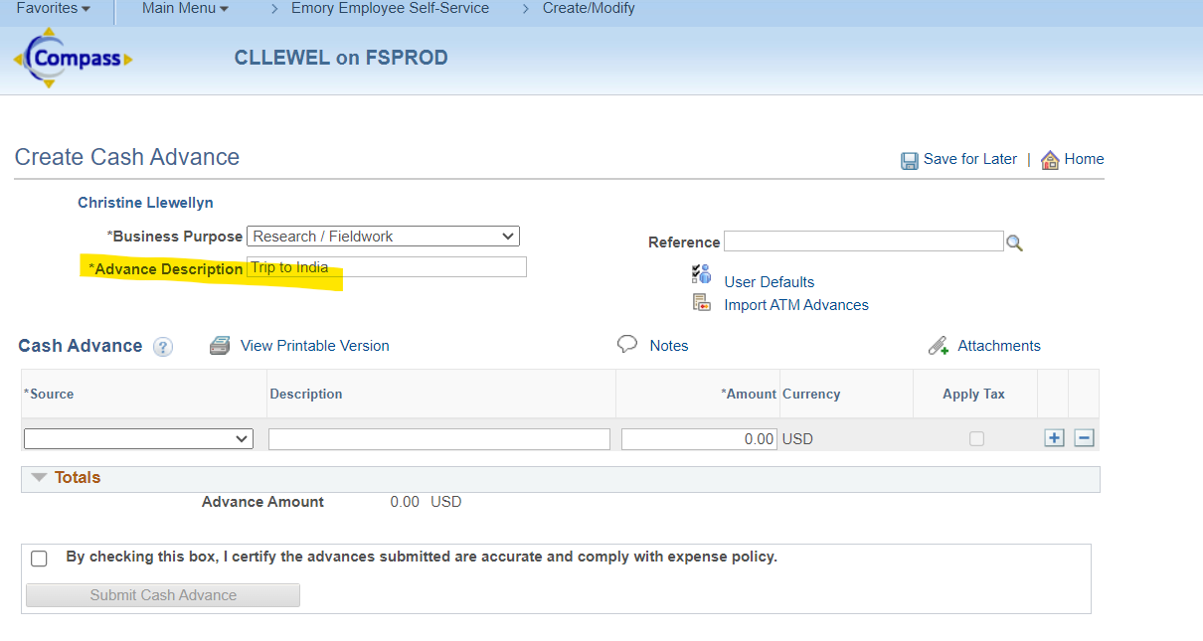

- Reference Field
- Click on the Search icon next to the Reference field to select the type of advance this pertains to, i.e., Non-Travel or Travel.
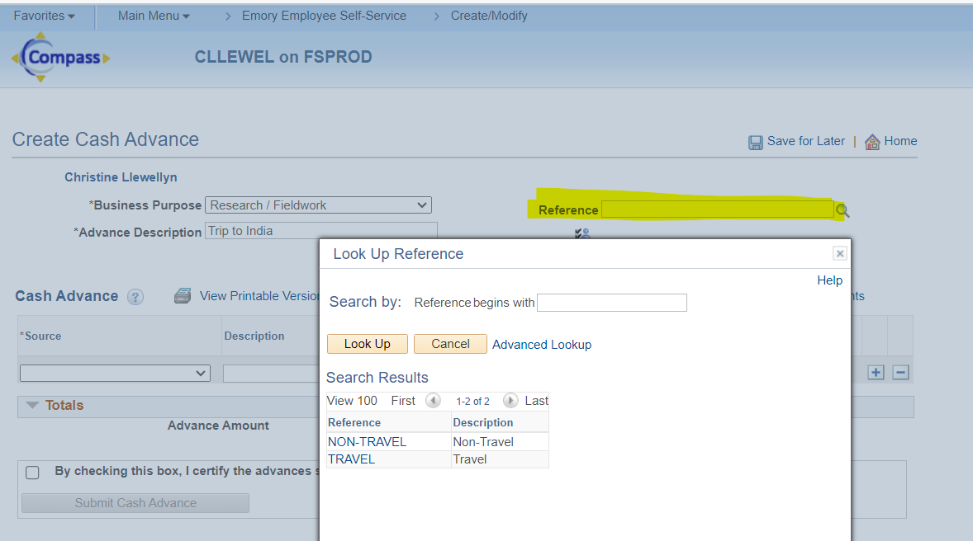

- Source Field
- When you click on the drop-down arrow in the Source field, only one option is shown – Check. This is for default purposes only. The cash advance will be delivered to you in the same form of payment as you receive your paycheck, which is normally a direct deposit.

- Description Field
- The Description field is not mandatory to be completed.
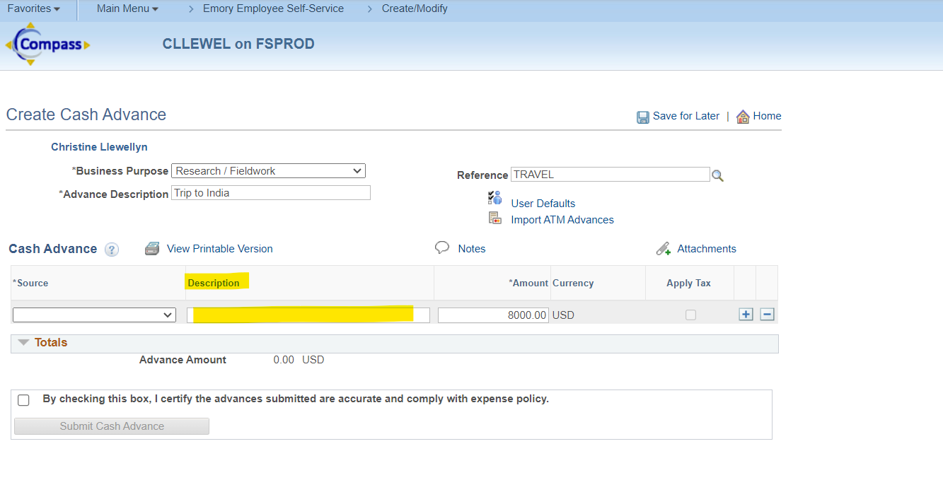

- Amount Field
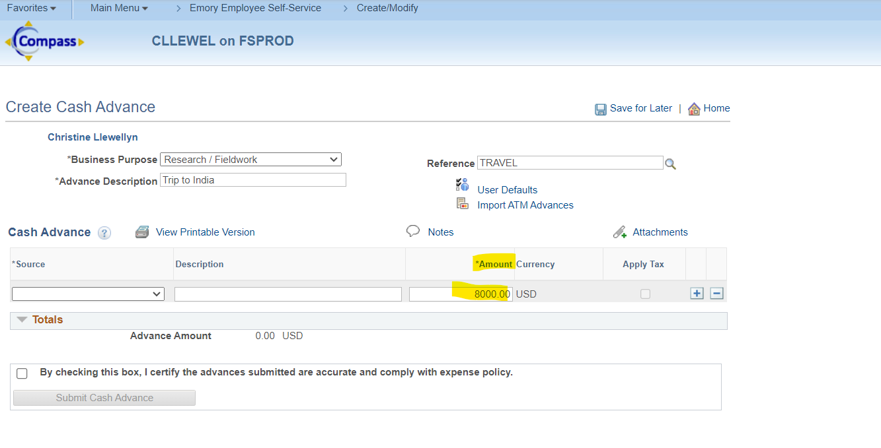
- In the Amount field, enter the amount of the travel cash advance that you need. All funds are issued in U.S. currency.
- Attachments
- Click on the Attachments Link to upload the two required travel cash advance documents:
  - Travel Cash Advance Request Form
  - Travel Cash Advance Request Agreement
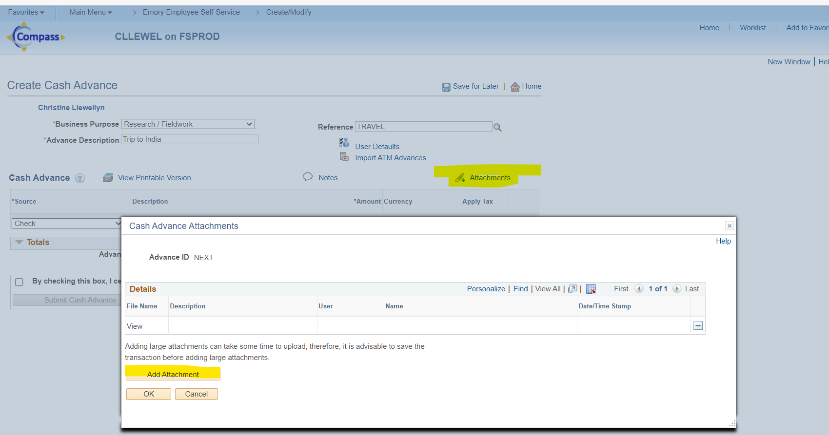

After you click on Add Attachments, the File Attachment box will be retrieved.
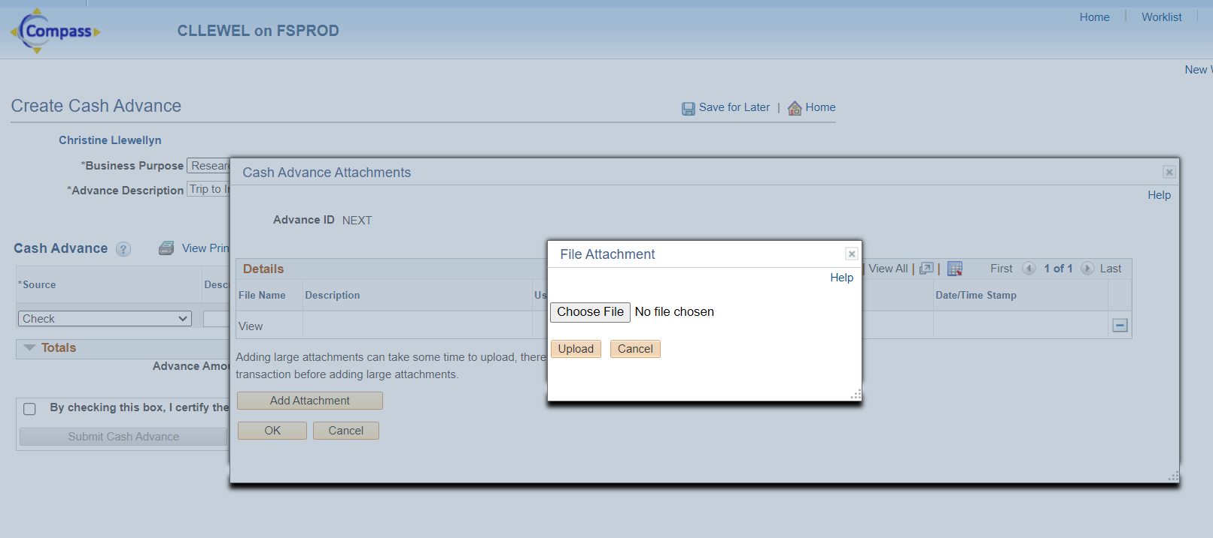
- Click Choose File.

- Find the files you need on your computer and then click Upload to attach them to your travel cash advance request.
- When you are finished, click OK.
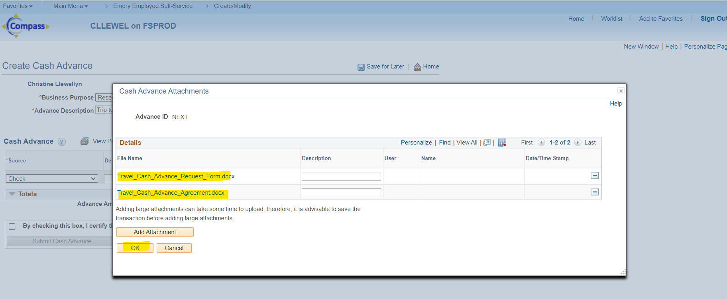

- Certify the Advance Request is Accurate
- When you are ready to submit your travel cash advance request, check the box in front of the statement “By checking this box, I certify the advances submitted are accurate and comply with expense policy.”
- Once you click on the box, it activates the Submit Cash Advance button.
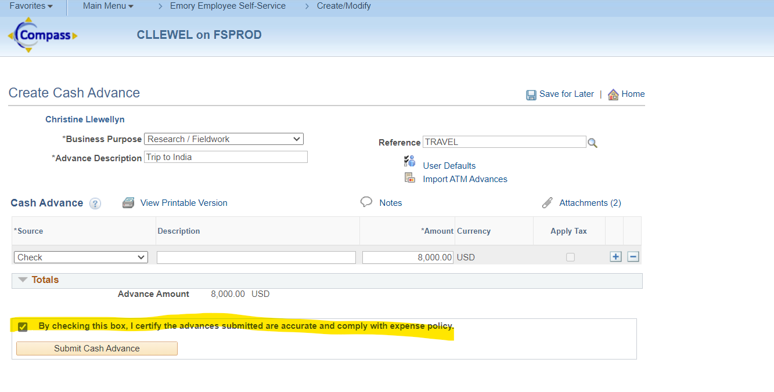

- Submit Cash Advance
- Click the Submit Cash Advance button.
Your cash advance request is placed in an Accounts Payable queue for review and approval.
